Master Functional Document

Application | NGERP - Centra
Service Bundle | Master Management
Service Request | Warehouse & Locator

Description :

This master is used to mange product like warehouse, locator and lot . Products can be maintained and monitored using this warehouse and locator master.

Workflow Process :

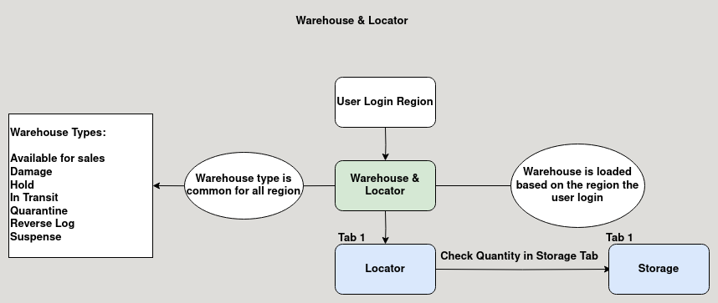

Business Rules :

- This Master is editable in regions only.
- User should login to their respective region to add warehouse or locator to that region.
- The warehouse type is common for all the region.

  - Available for Sales:
This type is Used for product Sales.
  - Damage:
This type is Used for product destruction.
  - Hold:
This type is Used for product Purchase.
  - In Transist:
This type is Used for sending and receiving branch transfer.
  - Quarantine:
This type is Used for near expiry product.
  - Reverse Log:
This type is Used when returning products both customer and vendor return.
  - Suspense:
This type is Used for stock adjustment.
- Warehouse for each region can be used identified with prefix Example: HCM, HNI etc ..
- Locator can be added to warehouse, each warehouse can have multiple locators.
- User can track the stock in micro level by warehouse, locator, lot.

